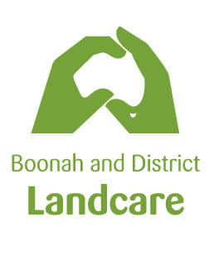

Application for Membership
Year 2022
Boonah and District Landcare Association Inc.
Applicant Details
First Name: | Last Name:
Address:
Date of Birth: | Phone:
Email:
Next of Kin Details:
First Name: | Last Name:
Relationship: | Phone:
Applicant Health Details: Please note any known allergies and/or medical conditions that should be disclosed, especially if engaged in fieldwork.
Areas of interest (please circle):
Regenerative Land Management Soil Health Tree Planting/Revegetation
Weed Removal/Clean up Waterways Healthy habitats
Other: ___________________________
Please note any skills/qualifications you would be willing to contribute: e.g. organisational skills, public relations, IT skills, fauna and flora ID, woodworking, catering, safe use of chainsaw/chemicals etc

Do you have a Bluecard? NO YES/Expiry Date

Applicant Signature Date:
Annual Fee: $10.00 annual Date of payment:
Boonah and District Landcare Association  BSB 633000 Account number 113860704 | Postal Address: Boonah and District Landcare Association Inc, LPO Box 284, BOONAH 4310

